Let’s Enjoy Dialoguing”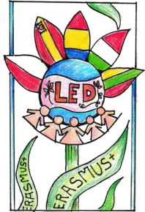

Second Year Project: Students’ Mid Evaluation Questionnaire

Country:……………………………………………..… Age:………………….
1. Have you been involved at this stage in the project? How? (Multiple selection if needed)

- Created posters
- Hosted a pupil
- Participated in dissemination activities
- Participated in group discussions and debates
- Published materials on the school’s web page
- Visited partner school
- Worked on creating and publishing the project’s blog
- Worked on communication activites
- Worked on the play “A story of our own”
- Wrote article for the newspapers
- Wrote essays

2. What are the advantages for you as a result of your involvement in this project?

- Enjoyed using English language for communication
- Discover English language could be fun and useful
- Became aware of my European identity
- Became more tolerant and open-minded
- Got rid of my own prejudices and stereotypes
- Learned about partner countries and their culture
- Learned more about my own country
- Made new friends
- Visited partner school/foreign country

3. What subjects are involved in the project?

- Information and Communication Technology (ICT)
- Art and Design
- English Language and Literature
- Geography
- History
- Music

4. Is the participation in the project helping you increase your foreign language skills ?
Yes No
5. Is the participation in the project helping you to increase your ICT or other technological skills?
Yes No
5. Is the participation in this project helping to increase your motivation, self-confidence or social skills? Please specify.

- Increased motivation and enthusiasm
- Self-confidence
- Self-confidence with use of English language
- Social skills
- Teamwork was helpful

6. Are you making any new friends during the project?
Yes No
7. Is this project enhancing your sense of belonging to the European Community?
Yes No

