Evaluation Questionnaire of the Meeting in Gravina in Puglia

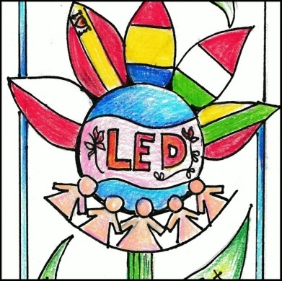
This questionnaire is an introduction to the process of evaluation. Questions that you are going to answer will be helpful in expressing your expectations connected to our partnership.
Country: ……………

Please fill in:
1 2 3 4 5
Very Low Low Medium High Very hig
_______________________________________________________
1. General organization during the meeting
Duration and timing of the meeting: 1, 2, 3, 4, 5
Domestic arrangements (accommodation, meals etc.) 1, 2, 3, 4, 5
Any other comments, suggestions for next meeting, for the future: 1, 2, 3, 4, 5
The subjects discussed were relevant: 1, 2, 3, 4, 5

2.The activities
Facilitated understanding of the objectives and work plan for the next period : 1, 2, 3, 4, 5
The meeting fulfilled the established objectives: 1, 2, 3, 4, 5
The meeting fulfilled my personal expectations : 1, 2, 3, 4, 5
What activities/subjects did you find most useful?

What activities/subjects did you find least useful?

Organization of practical activities at each project meeting: 1, 2, 3, 4, 5

2.Quality of European partnership
Effective communication amongst partners: 1, 2, 3, 4, 5
Development of teamwork, of positive attitudes: 1, 2, 3, 4, 5
The commitment to the project by each partner (fulfilling the responsibilities set out for this project meeting, quality of the presentations and products, sharing responsibility for the meeting) 1, 2, 3, 4, 5
Intercultural interaction: 1, 2, 3, 4, 5

3.Management and coordination
The information (on tasks, materials for the meeting etc.) received before the meeting from the coordinator: 1, 2, 3, 4, 5
The coordinator facilitate understanding of the objectives and work plan for the next period: 1, 2, 3, 4, 5
The coordinator facilitates communication and collaboration between partners: 1, 2, 3, 4, 5
Everyone was encourages to contribute to discussion: 1, 2, 3, 4, 5
Any other comments, suggestions for next meeting, for the future:

4. What will You take home with you?
- Good memories of hosting town/country
- New ideas and inspiration for further work
- Useful discussion/information/exchange of experience, ideas, methods
- New contacts/friends
- New partners/ideas for other projects and activities
- New knowledge/information about different European people and civilizations
- Good atmosphere
- Motivation for doing this
- New ideas for implementing and coordination European projects 9 Other

