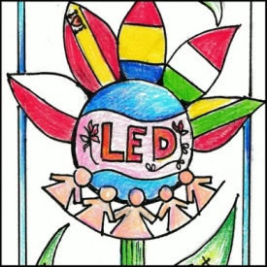

Erasmus + Project

“Let’s Enjoy Dialoguing”

MID EVALUATION QUESTIONNAIRE FOR TEACHERS

February 2018

Country:_____________

- This step of the project has been:
□Easy to realize
□Difficult and complicated
□Difficult but challenging and interesting
□Boring

- What has been the most difficult task to prepare the activities for the mobility in Gravina?

- Do you think this project of European cooperation is having a positive impact on your school community?
□Yes
□No
□I don’t know

- How are the tasks organized in your school in this second year of the project?

- Have there been changes in the teachers and the students involved?

- What problems have you faced?

- Are you having problems with the different supports to disseminate the project at your school?

- List some of the activities you have been doing this term so far

